What different image AI models really do with the same prompt
Why side-by-side output comparison matters more than benchmarks
Linda Zhang

Generative image models are everywhere—from design workflows and marketing to product prototyping and demos. When teams evaluate these models, they’re often guided by benchmark scores, curated examples, or polished vendor demos.
At Microsoft Build 2026, Mustafa Suleyman announced MAI-Image 2.5, Microsoft's latest flagship image generation model, introducing advances in image quality, prompt fidelity, controllable editing, identity preservation, and text rendering. That announcement immediately raised a practical question: how does MAI-Image 2.5 actually perform when placed side by side with other leading image generation models using the exact same prompt?
Rather than relying on benchmarks or vendor-selected examples, I wanted to answer a simpler, more actionable question one that frequently comes up in real customer conversations:
What do different image models actually produce when you give them the exact same prompt?
To explore this, I ran a controlled, output-only comparison across multiple text-to-image models using a single shared prompt. Every model received identical input—no prompt tuning, no post-processing, and no reliance on vendor claims. The evaluation focuses entirely on what appears in the generated images and the trade-offs each model makes when interpreting realism, constraints, and intent.

The setup: one prompt, multiple models
The prompt
All models received the same input:
“A shiba inu dog runs in Central Park, New York City. Its color is yellow brown. She has a golden metal neck collar. She is happy.”
This prompt is intentionally simple but specific. It tests several capabilities at once:
- Recognizing a concrete subject
- Depicting motion (running)
- Grounding a scene in a real location
- Following physical constraints (color, material)
- Conveying emotional expression
Models included
This comparison includes a mix of widely used, enterprise-relevant, and technically distinct image generation models:
- Firefly Image 5
- Gemini 3.1 (Nano Banana 2)
- FLUX-2 Pro
- FLUX-1 Kontext-Pro
- GPT-Image-1.5
- MAI-Image 2.5
- DALL·E 3

How the images were evaluated
Each image was reviewed using a simple scoring rubric derived directly from the prompt. The goal wasn’t to rank models or declare a winner, but to make differences visible in a structured and explainable way.
Evaluation criteria
Each image was scored from 0 to 5 on five criteria:
- Running (action) – Is the dog clearly running, with visible motion cues?
- Central Park + NYC (location) – Does the scene convincingly read as Central Park and New York City?
- Color accuracy – Is the coat clearly yellow-brown?
- Golden metal collar – Is the collar visible, gold, and metallic?
- Happiness (emotion) – Do expression and posture convey happiness?
Scoring was based solely on what was visible in the image. While image interpretation is inherently subjective, applying the same criteria consistently across all outputs makes relative strengths and tradeoffs easier to see.

Cross-model comparison at a glance
All images below were generated using the same prompt, with no prompt tuning or post-processing. Differences reflect how each model interprets realism, constraints, and intent.
Visual comparison
(Images embedded here, each with model name and caption.)
FLUX-2 Pro

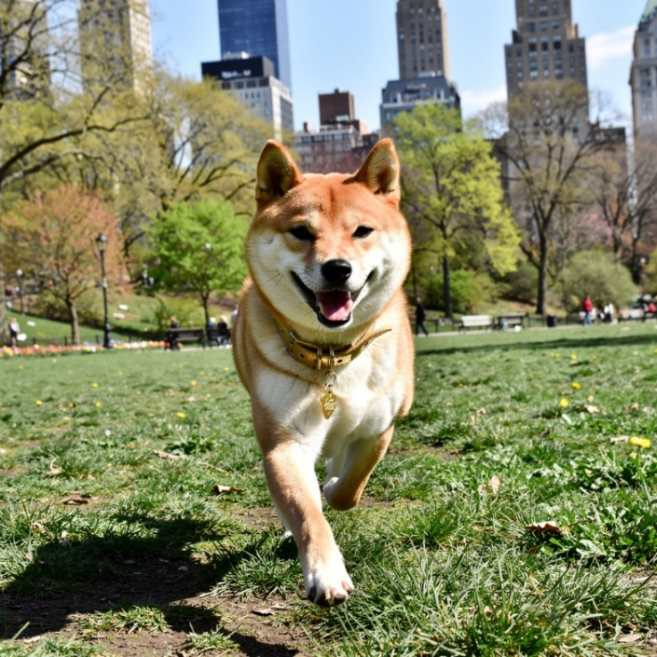
Image generated by FLUX-2 Pro showing a shiba inu running through Central Park with visible motion, ground interaction, and an urban background.

Firefly Image 5
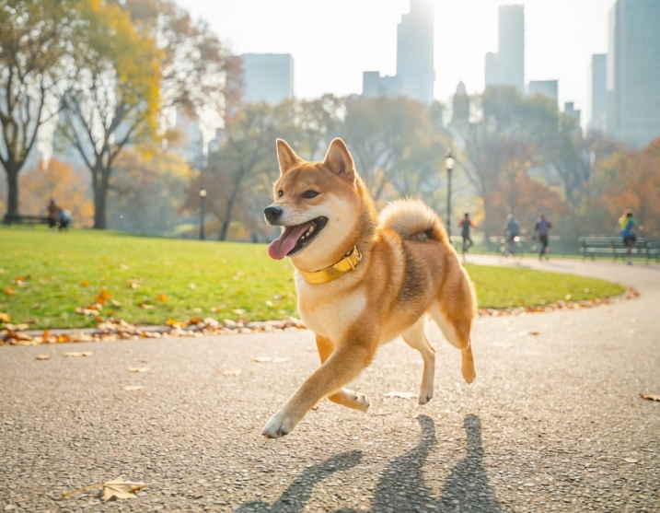
Image generated by Firefly Image 5 showing a shiba inu running in Central Park with clear location cues, clean composition, and a polished visual style.

Gemini 3.1 (Nano Banana 2)

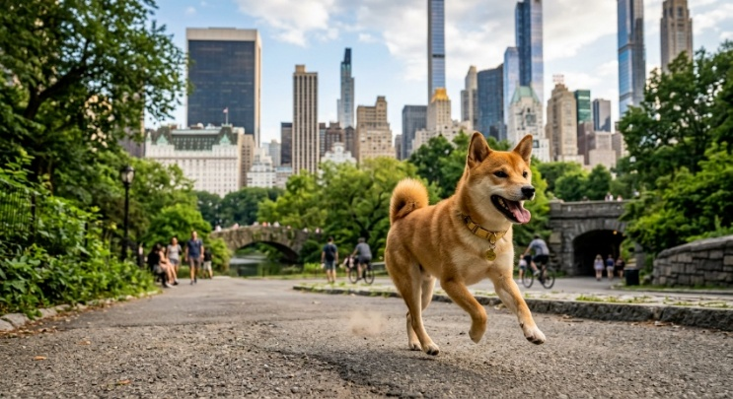
Image generated by Gemini 3.1 showing a shiba inu running in a park setting with cinematic lighting, strong contrast, and visible city elements.

DALL·E 3

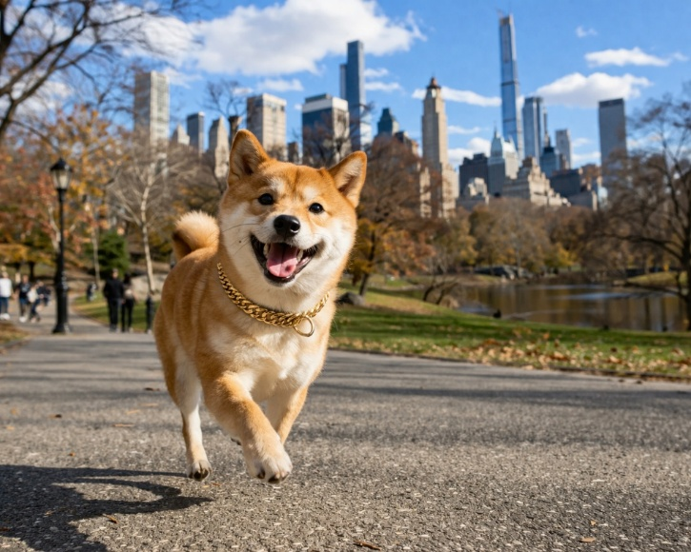
Image generated by DALL·E 3 showing a happy shiba inu in a park environment with expressive posture and a more interpretive visual style.

MAI-Image 2.5

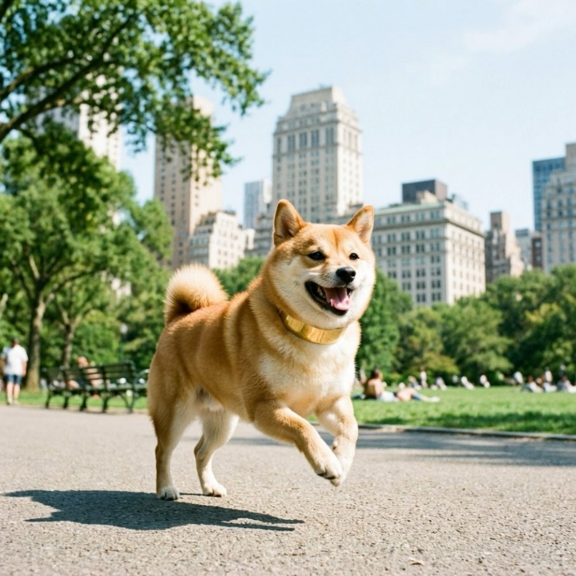
Image generated by MAI-Image 2.5 showing a shiba inu in a park environment with a visible golden collar and happy expression, presented in a more centered and composed scene with limited motion cues.

GPT-Image-1.5

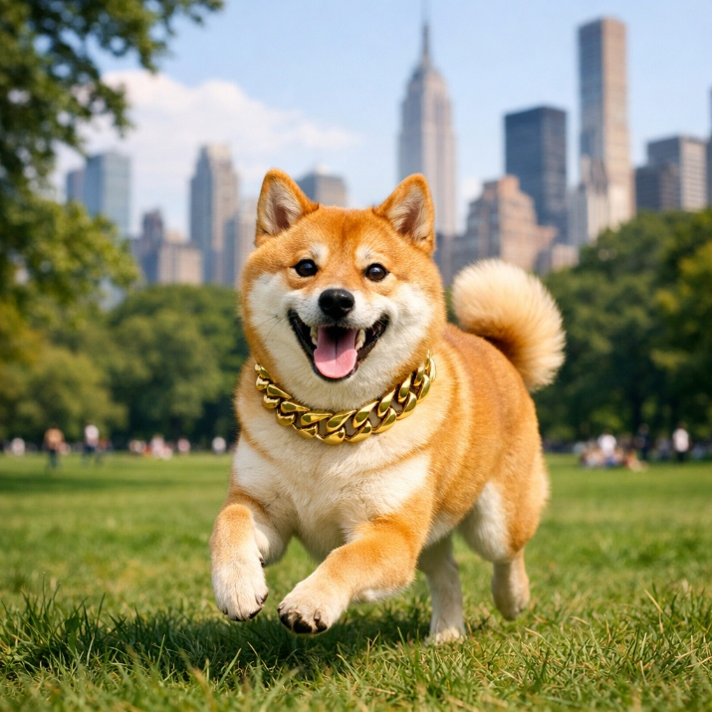
Image generated by GPT-Image-1.5 showing a shiba inu running in a park setting with accurate color and accessories, balanced composition, and moderate motion emphasis.

FLUX-1 Kontext-Pro

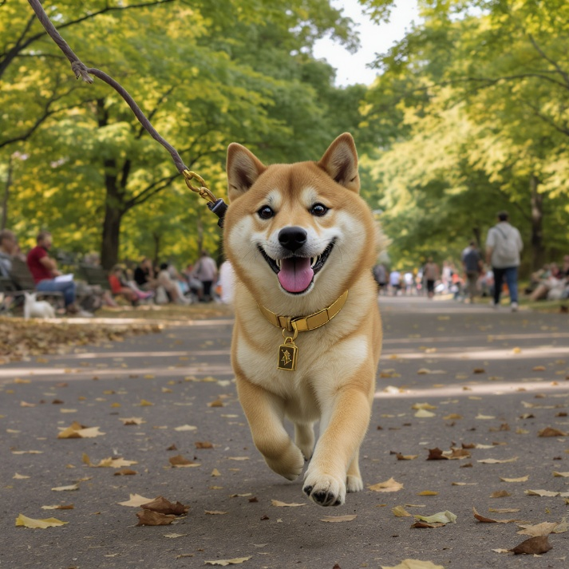
Image generated by FLUX-1 Kontext-Pro showing a shiba inu in mid-run with strong motion realism and subject detail, set in a park environment with subtle urban background cues.

Summary table
Rather than focusing only on numeric scores, the table below summarizes what each model tends to do well—and where it makes tradeoffs.
When viewed side by side, these outputs make the differences between models immediately clear—revealing how each one balances realism, constraints, and creative interpretation in practice.

Model | What it does well | Typical tradeoff
FLUX-2 Pro | Strong motion realism, physical grounding, environmental depth | Slightly less polished or brand-safe styling
Firefly Image 5 | High prompt fidelity, clean composition, brand-safe aesthetics | Less emphasis on dynamic motion
Gemini 3.1 (Nano Banana 2) | Balanced fidelity with cinematic contrast and lighting | Similar limitations to Firefly on motion intensity
FLUX-1 Kontext-Pro | Convincing subject realism and movement | Urban or location cues can be less explicit
GPT-Image-1.5 | Strong semantic accuracy and visual polish | Motion realism is present but more restrained
MAI-Image 2.5 | Clear subject, accessories, and emotional expression | Composed scenes over dynamic action
DALL·E 3 | Expressive, visually appealing, emotionally rich images | More interpretive; weaker constraint adherence

What this comparison reveals
Looking at the images side by side, several patterns stand out:
- Some models prioritize literal prompt adherence and brand safety
- Others emphasize physical realism and motion
- Some favor emotional tone and artistic interpretation over strict constraints
Importantly, there is no single “best” model across all dimensions. Each makes different tradeoffs, and those tradeoffs matter depending on the intended use case.

Why this matters for customers
For teams evaluating image generation models, this kind of comparison offers practical benefits:
- It makes differences easier to explain to stakeholders
- It surfaces tradeoffs early, before deep integration or optimization
- It supports faster, more confident decision-making
- It complements benchmarks by showing real-world behavior
This approach has been especially useful for early evaluations, demo preparation, and internal alignment—before investing heavily in prompt engineering or production pipelines.

Final takeaway
At Microsoft Build 2026, Microsoft introduced MAI-Image 2.5, highlighting how quickly image-generation models are advancing across quality, prompt fidelity, controllable editing, and production-ready workflows.
When it comes to image generation, the prompt is only half the story.
As this comparison shows, models can respond very differently to the same instruction. Some prioritize prompt adherence, some emphasize realism and motion, and others lean into visual polish, emotional tone, or creative interpretation.
That is why side-by-side evaluation remains so useful. A shared prompt and transparent rubric move the conversation beyond benchmarks, marketing claims, or curated demos and keep the focus where it belongs: on the images themselves.
As image generation enters a new phase with models such as MAI-Image 2.5, the most important question is no longer which model is “best” overall, but which model is best for the job at hand.

Community discussion
If you’ve run similar comparisons—or use different criteria when evaluating image models—I’d love to hear what’s worked (or not) in your environment.

